**ONLINE COURIER MANAGEMENT SYSTEM**

**Design Document**

**Version 1.0**



**Group Id :**

**Supervisor Name :**

**Revision History**

|  |  |  |  |
| --- | --- | --- | --- |
| **Date (dd/mm/yyyy)** | **Version** | **Description** | **Tested By** |
| **9/1/2024** | **1.0** |  |  |
|  |  |  |  |
|  |  |  |  |
|  |  |  |  |

**Table of Contents**

1. Introduction of Design Document
2. Entity Relationship Diagram (ERD)
3. Sequence Diagrams
4. Architecture Design Diagram
5. Class Diagram
6. Database Design
7. Interface Design
8. Test Cases

1. Introduction of Design Document

The Design Document maps the requirements into architecture-independent of how these requirements will be accomplished. The architecture defines the components, their interfaces, and behaviors. In the Design Phase, we transform the requirements gathered during the Analysis Phase into a Design Document that accurately describes the design of the system.

The purpose of the Design Phase is to transform the requirements into complete and detailed system design specifications once the design is approved the Design Document will serve as input to the Development Phase. Tools and techniques used in this phase are listed below:

* ER Diagram
* Sequence Diagram
* Architecture Design Diagram
* Class Diagram
* Database Design
* Interface Design
* Test Cases

1. Entity Relationship Diagram (ERD)

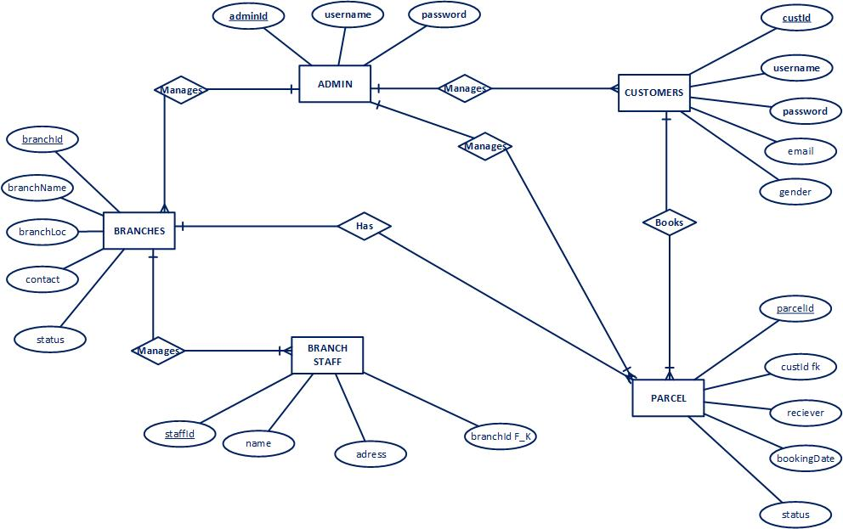

1. Sequence Diagrams

**REGISTER**

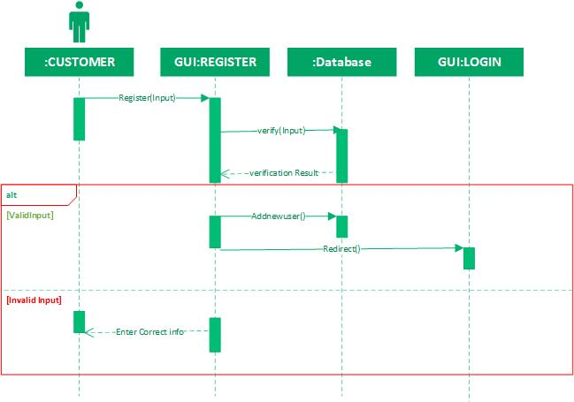

**LOGIN:**

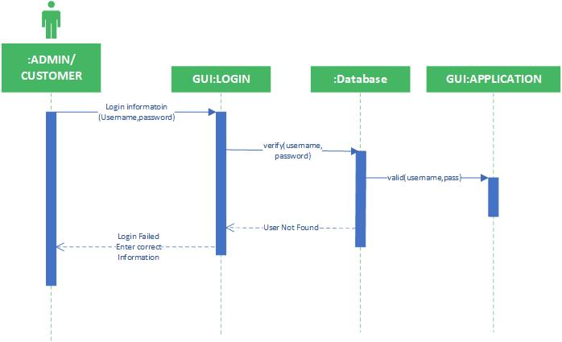

**ADD BRANCH:**

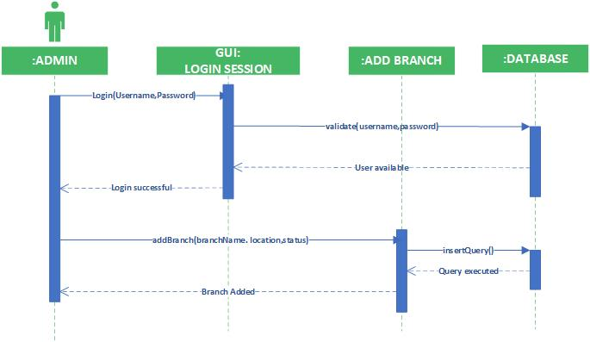

**ADD PARCEL:**

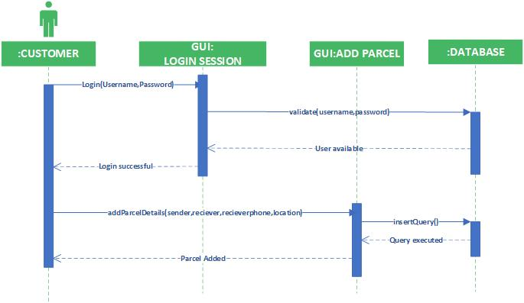

**ADD USER:**

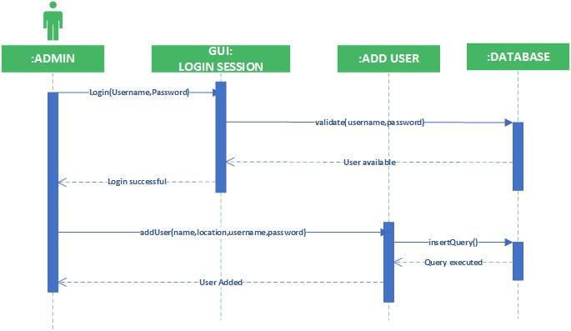

**MANAGE BRANCHES:**

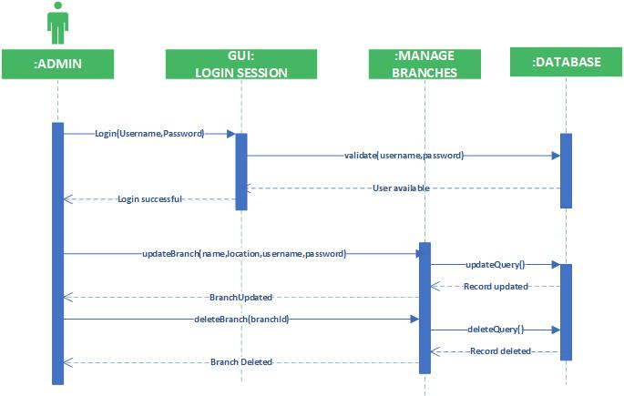

**MANAGE PARCEL:**

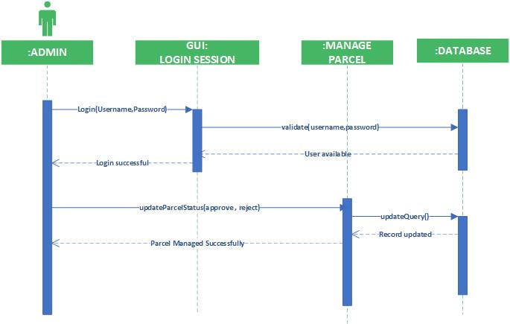

**MANAGE USERS:**

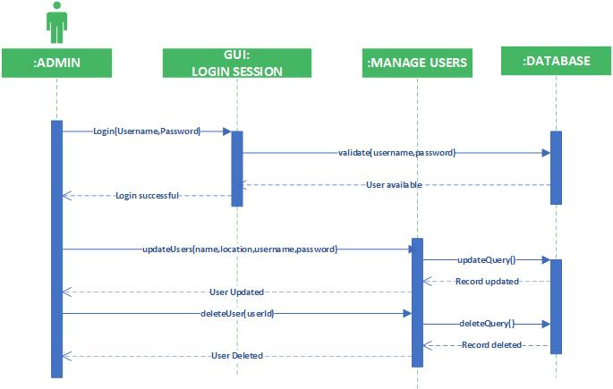

**LOGOUT:**

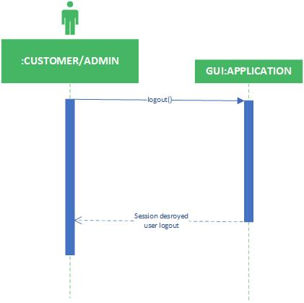

1. 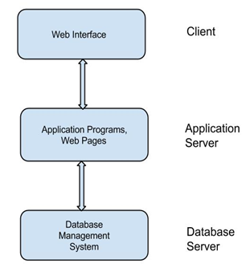Architecture Design Diagram
2. Class Diagram

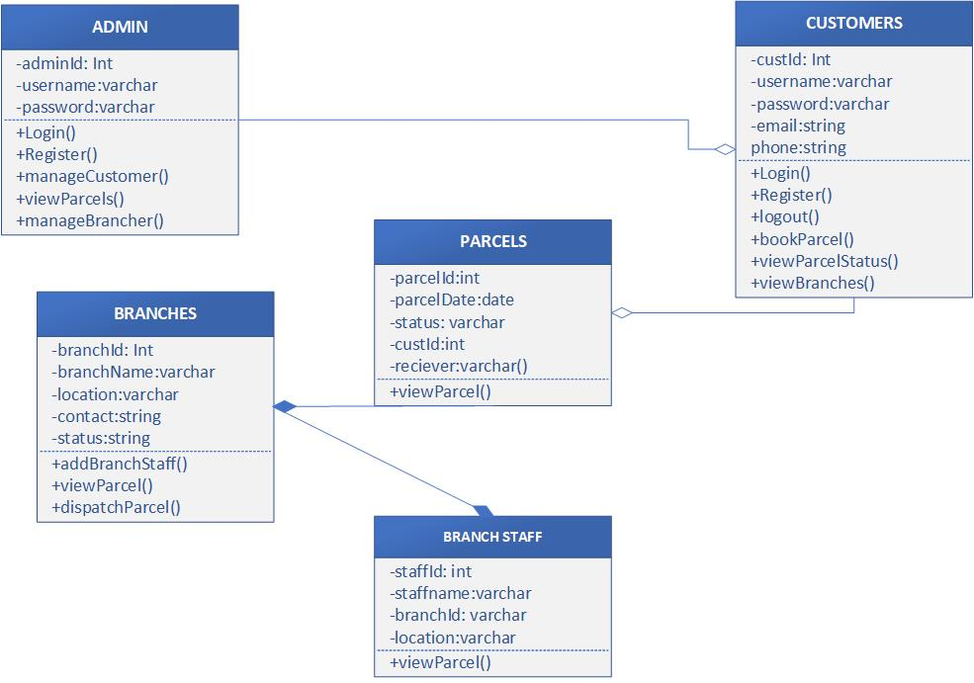

1. Database Design

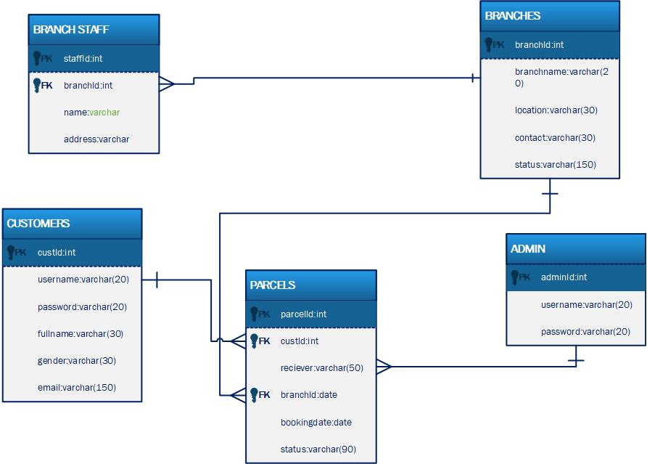

1. Interface Design
2. Test Cases

**REGISTER:**

|  |  |
| --- | --- |
| Pre-condition | Application interface must be available. |
| Action | 1. Open application interface of create account 2. Fill the form of registration 3. Click on “Register” button to get registered |
| Expected Results | Customer successfully created in database. |
| Results | Pass |
| Tested By | Irba Rizwan (BC220401818) |

**LOGIN:**

|  |  |
| --- | --- |
| Pre-condition | Actors must be registered with our website , Application interface must be available |
| Action | 1. Open application interface of login 2. Enter user name and password 3. Click on “Login” button |
| Expected Results | Actors successfully login and able to further work |
| Results | Pass |
| Tested By | Irba Rizwan (BC220401818) |

**ADD BRANCH:**

|  |  |
| --- | --- |
| Pre-condition | Admin user of the system must be registered with our website and logged in. |
| Action | 1. Login as Admin 2. Fill add branch form 3. Click on “Add New Branch” button |
| Expected Results | Branch successfully added in database and available to customers |
| Results | Pass |
| Tested By | Irba Rizwan (BC220401818) |

**ADD USER:**

|  |  |
| --- | --- |
| Pre-condition | Admin user of the system must be registered with our website and logged in. |
| Action | 1. Login as Admin 2. Fill add user form 3. Click on “Add User” button |
| Expected Results | Users successfully added and available on our website. |
| Results | Pass |
| Tested By | Irba Rizwan (BC220401818) |

**MANAGE USERS:**

|  |  |
| --- | --- |
| Pre-condition | Application interface must be available. And system must be logged in as Admin |
| Action | 1. Open application interface of create account 2. View manage_user.php page 3. Select Particular user to manage 4. Perform your desired actions(edit/delete) |
| Expected Results | Updated information added in database. |
| Results | Pass |
| Tested By | Irba Rizwan (BC220401818) |

**MANAGE BRANCHES:**

|  |  |
| --- | --- |
| Pre-condition | Application interface must be available. And system must be logged in as Admin |
| Action | 1. Open application interface of create account 2. View manage_branches.php page 3. Select Particular branch to manage 4. Perform your desired actions(edit/delete) |
| Expected Results | Updated information of branch is added in database. |
| Results | Pass |
| Tested By | Irba Rizwan (BC220401818) |

**VIEW REPORTS:**

|  |  |
| --- | --- |
| Pre-condition | Application interface must be available. And system must be logged in as Admin |
| Action | 1. Open application interface of create account 2. Click on “View Reports” button 3. Select Your desired report i.e monthly daily etc |
| Expected Results | Reports generated successfully. |
| Results | Pass |
| Tested By | Irba Rizwan (BC220401818) |

**MANAGE PARCEL:**

|  |  |
| --- | --- |
| Pre-condition | Application interface must be available. And system must be logged in as Admin |
| Action | 1. Open application interface of create account 2. View manage_parcels.php page 3. Select Particular Parcel to manage 4. Perform your desired actions(Add status of the parcel) |
| Expected Results | Status of parcel is Upated and added in database. |
| Results | Pass |
| Tested By | Irba Rizwan (BC220401818) |

**ADD PARCEL:**

|  |  |
| --- | --- |
| Pre-condition | Application interface must be available. And system must be logged in as Customer |
| Action | 1. Open application interface and open add parcel interface 2. Add details of parcel i.e sender name , receiver name, parcel details, parcel weight in a web form 3. Click on Add parcel |
| Expected Results | Parcel submitted and available for customer to view status |
| Results | Pass |
| Tested By | Irba Rizwan (BC220401818) |

**VIEW PARCEL:**

|  |  |
| --- | --- |
| Pre-condition | Application interface must be available |
| Action | 1. Open application interface select the view parcel tab. 2. Details of all parcel are visible to customers |
| Expected Results | Details of all parcel sent / received to be make visible to customers |
| Results | Pass |
| Tested By | Irba Rizwan (BC220401818) |

**TRACK PARCEL:**

|  |  |
| --- | --- |
| Pre-condition | Application interface must be available |
| Action | 1. Open application interface select the view parcel tab. 2. Select your desired parcel 3. Current status of the parcel is visible to customer |
| Expected Results | Status of all parcel sent / received to be make visible to customers |
| Results | Pass |
| Tested By | Irba Rizwan (BC220401818) |

**LOGOUT**

|  |  |
| --- | --- |
| Pre-condition | The application interface must be available and any of the actor must be Logged in. |
| Action | 1. Open application interface. 2. Click on Logout Button. |
| Expected Results | Session is destroyed and actor will be logout from system. |
| Results | Pass |
| Tested By | Irba Rizwan (BC220401818) |